**Software Requirements Specification**

**Project Name: JOB PORTAL SYSTEM**

**Date: 19-10-2023**

**Prepared by: Ajmal K**

**Company: Aitrich Technology**

|  |  |  |
| --- | --- | --- |
| SI | **Table of Contents** | Page No |
|  |  |  |
| 1 | Introduction | 2 |
|  | 1.1- Purpose | 2 |
|  | 1.2- Scope | 2 |
|  | 1.3- Objectives | 3 |
| 2 | Functional Requirements | 3 |
|  | 2.1- Primary Actors Of The System | 3 |
|  | 2.2- Use Case Diagram | 3-6 |
|  | 2.3- User Stories | 7 |
|  | 2.4- Business Process Diagram | 7-8 |
| 3 | Non-Functional Requirements | 9 |
| 4 | Technical Requirements | 9 |
| 5 | Conclusion | 9 |

**JOB PORTAL**

Software Requirements Specification

# **1. Introduction**

A job portal system is an online platform designed to connect job seekers with employers, providing a centralized hub for job search, recruitment, and employment-related activities. This document outlines the requirements for the development of the Online Job Portal System

* 1. Purpose

The purpose of this SRS is to:

* + - Define the functionalities of the Job Portal System.
    - Describe user roles, features, and interactions.
    - Establish a clear understanding of the system's scope and constraints.
  1. Scope
* Scope of the Job Portal System

The Job Portal System will include the following features:

* Job Seeker Module: Registration, profile management, job search, application submission, and job recommendations.
* Employer Module: Registration, job posting, applicant management, and messaging.
* Admin Module: User management, content moderation, and reporting.
* System notifications and alerts.
* Data analytics for employers.
* User support and FAQs.
* Limitations

The system will not include job applicant background checks or integrated payment processing

* User Roles

The system caters to three primary user roles: job seekers, employers, and administrators.

* 1. Objectives
* High-Level Objectives

The primary objectives of the Job Portal System are as follows:

* To provide a platform connecting job seekers and employers.
* To streamline the job search and recruitment process.
* To enhance user experience and engagement on the platform.
* Goals and Problems

The system aims to address the following goals and problems:

* Simplify job searching and application processes for job seekers.
* Improve applicant management and communication for employers.
* Ensure data security and privacy.
* Enhance system performance and scalability.
* Provide valuable data analytics to employers for efficient recruitment.

1. **Functional Requirements**
   1. Primary Actors

* Job Seekers
* Job Providers
* Platform Admin

2.2 Use Case Diagrams

JOB SEEKER

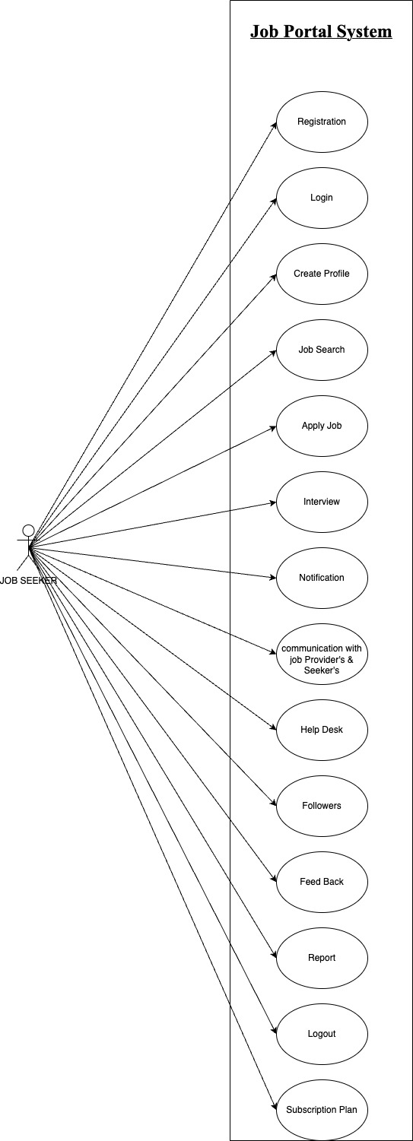

JOB PROVIDER

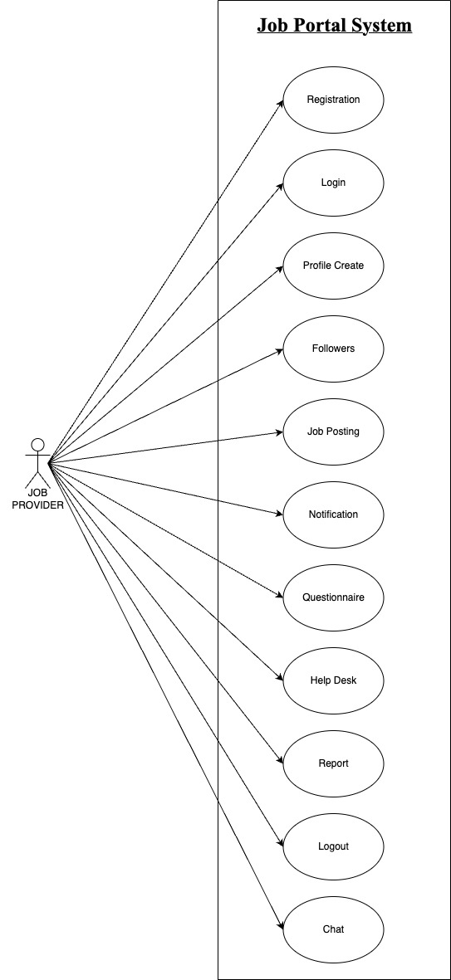

PLATFORM ADMIN

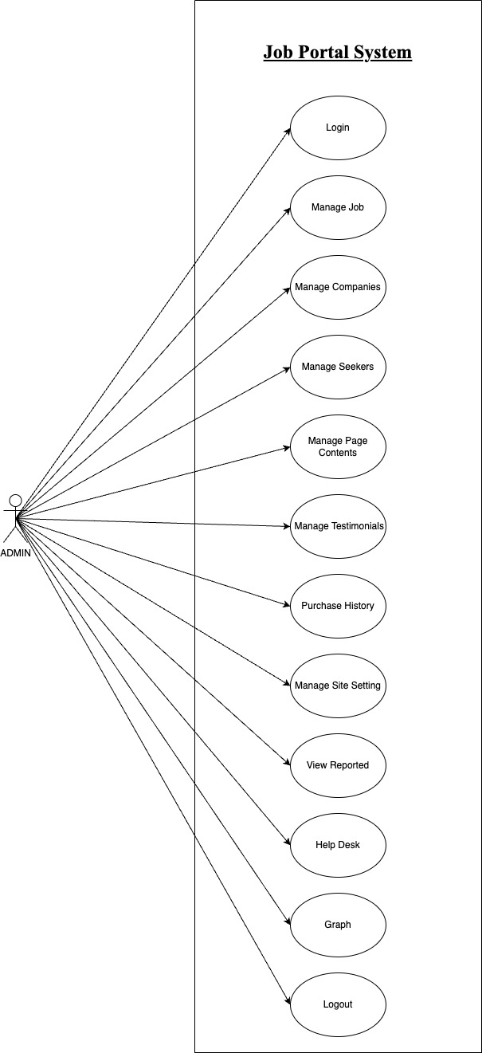

2.3 **User Stories**

|  |  |  |
| --- | --- | --- |
| As A [type of user] | I NEED TO [do some task] | SO THAT I CAN [get some result] |
| Job seeker | Login to the app as I registered | Enter my username & password to access my account |
| Job provider | Post a job on the job portal | Advertise job openings and attract employees |
| Platform Admin | Approve job providers before they can post job listings on the platform | Ensure the quality of job listings on the platform and prevent fake job posting |

2.4 **Business Process Diagram**

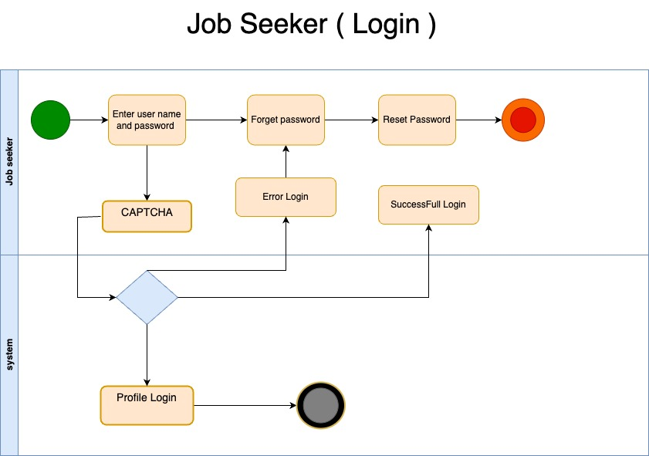

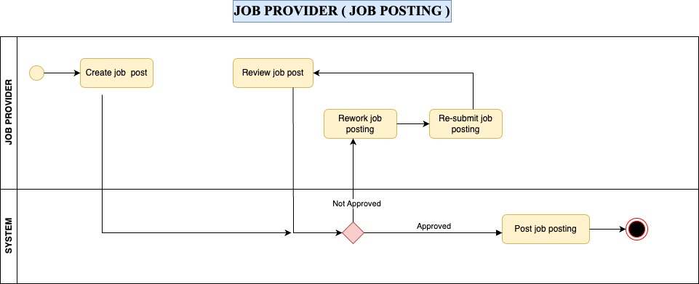



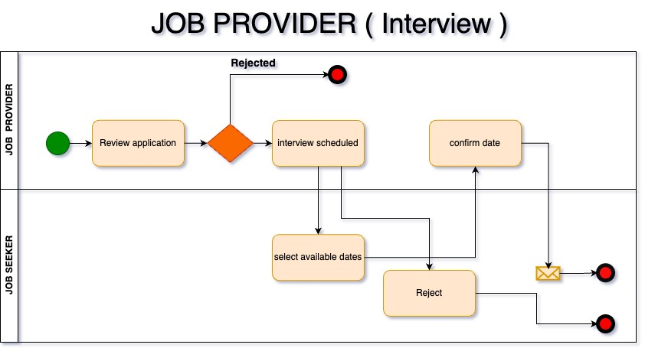

**3. Non-Functional Requirements**

* Performance:

The system should support a minimum of 500 concurrent users with response times below 2 seconds.

* Reliability:

The system should have a high uptime and minimal downtime for maintenance.

* Security:

User data must be securely stored and transmitted with appropriate encryption and access controls.

* Usability:

The user interface should be intuitive and user-friendly to enhance the user experience.

* Scalability:

The system should be scalable to handle increased user activity.

**4. Technical Requirements**

* **Software Stack**: The system will use a technology stack comprising HTML5, CSS3, JavaScript, React.js for the front-end, Node.js, Express.js for the back-end, and MySQL for the database.
* **Hosting**: The system will be hosted on an AWS infrastructure.
* **Compatibility**: The system will be compatible with major web browsers (e.g., Chrome, Firefox, Safari) and responsive on various devices (desktop, tablet, mobile).

**5. Conclusion**

In conclusion, the Job Portal System SRS outlines the objectives, functional and non-functional requirements, user stories, and technical requirements of the system. This document serves as a blueprint for the development team, ensuring that the system meets its objectives and addresses the identified goals and problems effectively. It sets the foundation for creating a user-friendly, secure, and efficient platform for job seekers and job providers.